**Institute of Computer Technology**

**Ganpat University**

**(2CSE301) DATABASE MANAGEMENT SYSTEM**

**Practical 12 MySQL Conditional Statements and Looping**

# Part A: Write the following queries using conditional statements

1. Create a procedure **“enrolmentnumber_q1”** to identify the grade of an employee. If an employee earns more than 8000, his grade should be 'A', if he earns between 5000 to 8000 then his grade is 'B', else his grade should be 'C'. **(e.g. if the user enters 100 as employee_id, he should get the result ‘A’)**

**DELIMITER //**

**create procedure enrolmentnumber_q1(in employee_id int, out grade char(1))**

**begin**

**declare earings decimal (10,2);**

**select salary into earings from employees**

**where employee_id = employee_id**

**limit 1;**

**if earings > 8000 then**

**set grade = 'A';**

**elseif earings >= 5000 and earings <= 8000 then**

**set grade = 'B';**

**else**

**set grade = 'C';**

**end if ;**

**end;**

**//**

**delimiter ;**

**set @grade = '';**

**call enrolmentnumber_q1(100, @grade);**

**select @grade;**

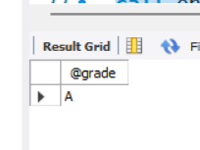

1. Create a procedure **“enrolmentnumber_q2”** to display the full country name based on user specified location ID as per below details: **(e.g., if user enters 1000, he should be shown ITALY)**

AR Argentina

AU Australia

BE Belgium

BR Brazil

CA Canada

CH Switzerland

CN China

DE Germany

DK Denmark

EG Egypt

FR France

HK HongKong

IL Israel

IN India

IT Italy

JP Japan

KW Kuwait MX Mexico

NG Nigeria

NL Netherlands

SG Singapore

UK United Kingdom

US United States of America

ZM Zambia

ZW Zimbabwe

delimiter //

create procedure enrol_q2(in location_id int)

begin

declare country_name varchar(255);

set country_name = (

case location_id

when 1000 then 'ITALY'

when 1001 then 'ARGENTINA'

when 1002 then 'AUSTRALIA'

when 1003 then 'BELGIUM'

when 1004 then 'BRAZIL'

when 1005 then 'CANADA'

when 1006 then 'SWITZERLAND'

when 1007 then 'CHINA'

when 1008 then 'GERMANY'

when 1009 then 'DENMARK'

when 1010 then 'EGYPT'

when 1011 then 'FRANCE'

when 1012 then 'HONGKONG'

when 1013 then 'ISRAEL'

when 1014 then 'INDIA'

when 1015 then 'ITALY'

when 1016 then 'JAPAN'

when 1017 then 'KUWAIT'

when 1018 then 'MEXICO'

when 1019 then 'NIGERIA'

when 1020 then 'NETHERLAND'

when 1021 then 'SINGAPORE'

when 1022 then 'UNITED KINGDOM'

when 1023 then 'UNITED STATES OF AMERICA'

when 1024 then 'ZAMBIA'

when 1025 then 'ZIMBAVE'

ELSE 'UNKNOWN'

end

);

SELECT country_name;

end;

//

delimiter ;

call enrol_q2(1000);

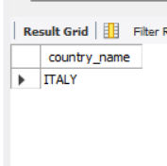

# PART B: Solve the following queries using CASE statement

3. Create a stored procedure “**enrolmentnumber_q3**” to display the region name based on region id as per following manner:

**(e.g. if a user enters 1, he should see the output like: "You are from Europe Region", if user enters a number which does not exist in database, then he should see the output like: "Region does not exist")**

**delimiter //**

**create procedure enrol_q3(in region_id int )**

**begin**

**declare region_name varchar(255);**

**set region_name = (**

**case region_id**

**when 1 then 'You are from Europe Region '**

**when 2 then 'You are from Asia Region'**

**when 3 then 'You are from North America '**

**when 4 then 'You are from South America'**

**when 5 then 'You are from Africa Region'**

**else 'Region does not exit'**

**end**

**);**

**select region_name;**

**end;**

**//**

**delimiter ;**

**call enrol_q3(1);**

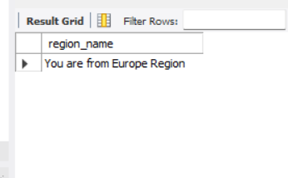

# PART C: Solve the following queries using loop

1. Create a stored procedure “**enrolmentnumber_q4**” to print numbers from 1 to 10 using WHILE loop.

delimiter //

create procedure enrol_q4()

begin

declare counter int default 1;

while counter <= 10 do

select counter ;

set counter = counter + 1 ;

end while;

end;

//

delimiter ;

call enrol_q4();

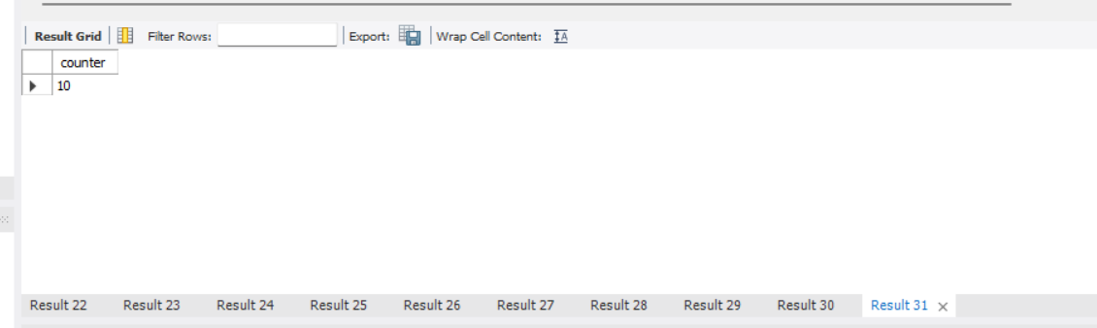

1. Create a stored procedure “**enrolmentnumber_q5**” to print numbers from 1 to 10 using LOOP statement.

delimiter //

create procedure enrol_q5()

begin

declare counter int default 1;

repeat

select counter;

set counter = counter + 1;

until counter > 10 end repeat;

end;

//

delimiter ;

call enrol_q5();

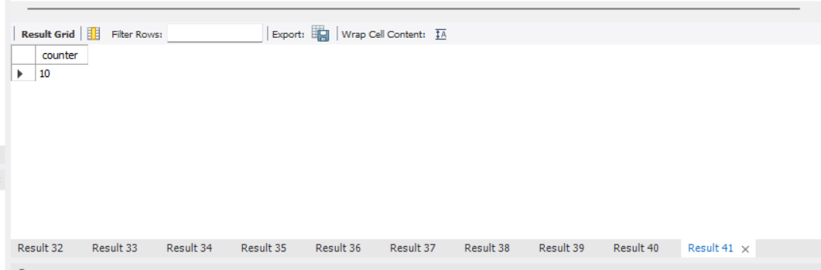

1. Create a stored procedure “**enrolmentnumber_q6**” to print even numbers from 1 to 20 using LOOP statement.

delimiter //

create procedure enrol_q6()

begin

declare counter int default 2;

while counter <= 20 do

select counter;

set counter = counter + 2;

end while ;

end;

//

delimiter ;

call enrol_q6();

